PERSONAL DATA
Your personal data might include
- Name
- Date of birth and place
- Aadhar number
- License number
- Username password
- Medical records
- Educational records
- Financial records

A hacker can access these records using various ways, for example incase you use weak passwords it very vulnerable to basic password attacks.
Other than being hacked your personal information is monitored by social medias and other online companies to give out personalized advertisements which is the trending marketing strategy right now. Example: if you search for a product in amazon or flipkart for a period of time you get pinged with same kind of advertisement on Instagram. These personal data transactions are done real time to give out advertisement as soon as possible when the client is actively searching for something.

ORGANISATOINAL DATA
Traditional Data
Traditional data is typically generated and maintained by all organizations, big and small. It includes the following:
- Transactional data such as details relating to buying and selling, production activities and basic organizational operations such as any information used to make employment decisions.
- Intellectual property such as patents, trademarks and new product plans, which allows an organization to gain economic advantage over its competitors. This information is often considered a trade secret and losing it could prove disastrous for the future of a company.
- Financial data such as income statements, balance sheets and cash flow statements, which provide insight into the health of a company.

Internet of Things (IoT) and Big Data
IoT is a large network of physical objects, such as sensors, software and other equipment. All of these ‘things’ are connected to the Internet, with the ability to collect and share data. And given that storage options are expanding through the cloud and virtualization, it’s no surprise that the emergence of IoT has led to an exponential growth in data, creating a new area of interest in technology and business called 'Big Data.'

THE CUBE
The McCumber Cube is a model framework created by John McCumber in 1991 to help organizations establish and evaluate information security initiatives by considering all of the related factors that impact them. This security model has three dimensions:
- The foundational principles for protecting information systems.
- The protection of information in each of its possible states.
- The security measures used to protect data.
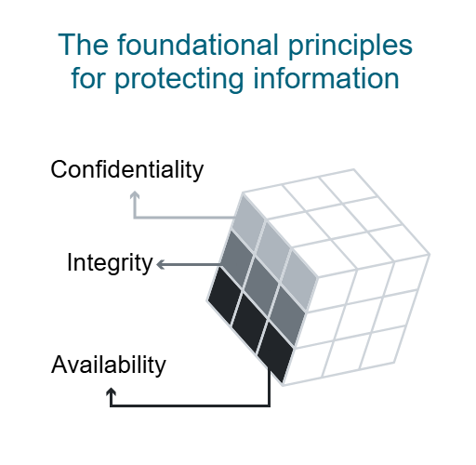

- Confidentiality is a set of rules that prevents sensitive information from being disclosed to unauthorized people, resources and processes. Methods to ensure confidentiality include data encryption, identity proofing and two factor authentication.

- Integrity ensures that system information or processes are protected from intentional or accidental modification. One way to ensure integrity is to use a hash function or checksum.

- Availability means that authorized users are able to access systems and data when and where needed and those that do not meet established conditions, are not. This can be achieved by maintaining equipment, performing hardware repairs, keeping operating systems and software up to date, and creating backups.

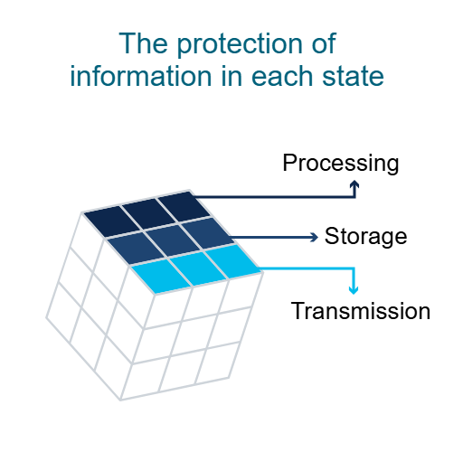
- Processing refers to data that is being used to perform an operation such as updating a database record (data in process).

- Storage refers to data stored in memory or on a permanent storage device such as a hard drive, solid-state drive or USB drive (data at rest).

- Transmission refers to data traveling between information systems (data in transit).

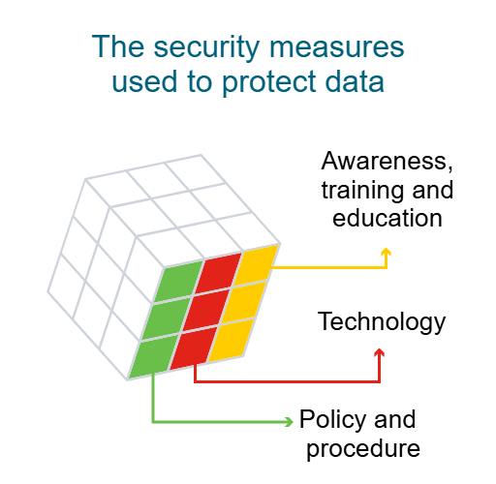
- Awareness, training and education are the measures put in place by an organization to ensure that users are knowledgeable about potential security threats and the actions they can take to protect information systems.

- Technology refers to the software- and hardware-based solutions designed to protect information systems such as firewalls, which continuously monitor your network in search of possible malicious incidents.

- Policy and procedure refers to the administrative controls that provide a foundation for how an organization implements information assurance, such as incident response plans and best practice guidelines.

Consequences of a Security Breach
- Reputational damage
- Vandalism
- Theft
- Loss of revenue
- Damage to intellectual property

The Purpose of Cyberwarfare
The main reason for resorting to cyberwarfare is to gain advantage over adversaries, whether they are nations or competitors.
To gather compromised information and/or defense secrets
A nation or international organization can engage in cyberwarfare in order to steal defense secrets and gather information about technology that will help narrow the gaps in its industries and military capabilities.
Furthermore, compromised sensitive data can give attackers leverage to blackmail personnel within a foreign government.
To impact another nation’s infrastructure
Besides industrial and military espionage, a nation can continuously invade another nation’s infrastructure in order to cause disruption and chaos.
For example, a cyber attack could shut down the power grid of a major city. Consider the consequences if this were to happen; roads would be congested, the exchange of goods and services would be halted, patients would not be able to get the care they would need if an emergency occurred, access to the internet would be interrupted. By shutting down a power grid, a cyber attack could have a huge impact on the everyday life of ordinary citizens.
Malware and types of malwares
  - Spyware: Designed to track and spy on you, spyware monitors your online activity and can log every key you press on your keyboard, as well as capture almost any of your data, including sensitive personal information such as your online banking details. Spyware does this by modifying the security settings on your devices.
It often bundles itself with legitimate software or Trojan horses.

  - Ransomware : This malware is designed to hold a computer system or the data it contains captive until a payment is made. Ransomware usually works by encrypting your data so that you can’t access it.
Some versions of ransomware can take advantage of specific system vulnerabilities to lock it down. Ransomware is often spread through phishing emails that encourage you to download a malicious attachment or through a software vulnerability.

  - Virus : A virus is a type of computer program that, when executed, replicates and attaches itself to other executable files, such as a document, by inserting its own code. Most viruses require end-user interaction to initiate activation and can be written to act on a specific date or time.
Viruses can be relatively harmless, such as those that display a funny image. Or they can be destructive, such as those that modify or delete data.
Viruses can also be programmed to mutate in order to avoid detection. Most viruses are spread by USB drives, optical disks, network shares or email.

  - Adware : Adware is often installed with some versions of software and is designed to automatically deliver advertisements to a user, most often on a web browser. You know it when you see it! It’s hard to ignore when you’re faced with constant pop-up ads on your screen.
It is common for adware to come with spyware.

  - Backdoor : This type of malware is used to gain unauthorized access by bypassing the normal authentication procedures to access a system. As a result, hackers can gain remote access to resources within an application and issue remote system commands.
A backdoor works in the background and is difficult to detect.

  - Scareware : This is a type of malware that uses 'scare’ tactics to trick you into taking a specific action. Scareware mainly consists of operating system style windows that pop up to warn you that your system is at risk and needs to run a specific program for it to return to normal operation.
If you agree to execute the specific program, your system will become infected with malware.

  - Rootkit : This malware is designed to modify the operating system to create a backdoor, which attackers can then use to access your computer remotely. Most rootkits take advantage of software vulnerabilities to gain access to resources that normally shouldn’t be accessible (privilege escalation) and modify system files.
Rootkits can also modify system forensics and monitoring tools, making them very hard to detect. In most cases, a computer infected by a rootkit has to be wiped and any required software reinstalled.

  - Trojan horse : This malware carries out malicious operations by masking its true intent. It might appear legitimate but is, in fact, very dangerous. Trojans exploit your user privileges and are most often found in image files, audio files or games.
Unlike viruses, Trojans do not self-replicate but act as a decoy to sneak malicious software past unsuspecting users.

  - Worms : This is a type of malware that replicates itself in order to spread from one computer to another. Unlike a virus, which requires a host program to run, worms can run by themselves. Other than the initial infection of the host, they do not require user participation and can spread very quickly over the network.
Worms share similar patterns: They exploit system vulnerabilities, they have a way to propagate themselves, and they all contain malicious code (payload) to cause damage to computer systems or networks.
Worms are responsible for some of the most devastating attacks on the Internet. In 2001, the Code Red worm had infected over 300,000 servers in just 19 hours.

Advanced Persistent Threats
Attackers also achieve infiltration through advanced persistent threats (APTs) — a multi-phase, long term, stealthy and advanced operation against a specific target. For these reasons, an individual attacker often lacks the skill set, resources or persistence to perform APTs.
Due to the complexity and the skill level required to carry out such an attack, an APT is usually well-funded and typically targets organizations or nations for business or political reasons.
Its main purpose is to deploy customized malware on one or more of the target’s systems and remain there undetected.

Security Vulnerabilities
Hardware Vulnerabilities
Hardware vulnerabilities are most often the result of hardware design flaws. For example, the type of memory called RAM basically consists of lots of capacitors (a component which can hold an electrical charge) installed very close to one another. However, it was soon discovered that, due to their close proximity, changes applied to one of these capacitors could influence neighbor capacitors. Based on this design flaw, an exploit called Rowhammer was created. By repeatedly accessing (hammering) a row of memory, the Rowhammer exploit triggers electrical interferences that eventually corrupt the data stored inside the RAM.
Meltdown and Spectre
Google security researchers discovered Meltdown and Spectre, two hardware vulnerabilities that affect almost all central processing units (CPUs) released since 1995 within desktops, laptops, servers, smartphones, smart devices and cloud services.
Attackers exploiting these vulnerabilities can read all memory from a given system (Meltdown), as well as data handled by other applications (Spectre). The Meltdown and Spectre vulnerability exploitations are referred to as side-channel attacks (information is gained from the implementation of a computer system). They have the ability to compromise large amounts of memory data because the attacks can be run multiple times on a system with very little possibility of a crash or other error.

SOFTWARE VULNERABILITIES
Software vulnerabilities are usually introduced by errors in the operating system or application code.
Types:
Buffer overflow:
Buffers are memory areas allocated to an application. A vulnerability occurs when data is written beyond the limits of a buffer. By changing data beyond the boundaries of a buffer, the application can access memory allocated to other processes. This can lead to a system crash or data compromise, or provide escalation of privileges.
Non validated input:
Programs often require data input, but this incoming data could have malicious content, designed to force the program to behave in an unintended way.
For example, consider a program that receives an image for processing. A malicious user could craft an image file with invalid image dimensions. The maliciously crafted dimensions could force the program to allocate buffers of incorrect and unexpected sizes.

Race conditions:
This vulnerability describes a situation where the output of an event depends on ordered or timed outputs. A race condition becomes a source of vulnerability when the required ordered or timed events do not occur in the correct order or at the proper time.

Weakness in security practices:
Systems and sensitive data can be protected through techniques such as authentication, authorization and encryption. Developers should stick to using security techniques and libraries that have already been created, tested and verified and should not attempt to create their own security algorithms. These will only likely introduce new vulnerabilities.

Access control problems:
Access control is the process of controlling who does what and ranges from managing physical access to equipment to dictating who has access to a resource, such as a file, and what they can do with it, such as read or change the file. Many security vulnerabilities are created by the improper use of access controls.
Nearly all access controls and security practices can be overcome if an attacker has physical access to target equipment. For example, no matter the permission settings on a file, a hacker can bypass the operating system and read the data directly off the disk. Therefore, to protect the machine and the data it contains, physical access must be restricted, and encryption techniques must be used to protect data from being stolen or corrupted.

FIREWALLS
In computer networking, a firewall is designed to control or filter which communications are allowed in and which are allowed out of a device or network. A firewall can be installed on a single computer with the purpose of protecting that one computer (host-based firewall) or it can be a standalone network device that protects an entire network of computers and all of the host devices on that network (network-based firewall).
TYPES
  - NETWORK LAYER: This filters communications based on source and destination IP addresses.
  - TRANSPORT LAYER: Filters communications based on source and destination data ports, as well as connection states.
  - APPLICATION LAYER: Filters communications based on an application, program or service.
  - CONTEXT AWARE LAYER: Filters communications based on the user, device, role, application type and threat profile.
  - PROXY SERVER: Filters web content requests like URLs, domain names and media types.
  - REVERSE PROXY SERVER: Placed in front of web servers, reverse proxy servers protect, hide, offload and distribute access to web servers.
  - NAT FIREWALL: This firewall hides or masquerades the private addresses of network hosts.
  - HOST BASED FIREWALL: Filters ports and system service calls on a single computer operating system.

